CMSC 204

Huffman Lab

Joshua Schlesinger-Guevara

1. Create a Huffman Tree and generate the codes for each character of the following input:

create a huffman tree

Letter : c r e a t h u f m n “space”

Frequency : 1 2 4 3 2 1 1 2 1 1 3

For consistency:

1. If same frequency – put in priority queue alphabetically; put space before other characters of the same frequency
2. Add subtrees to end of group with same priority
3. Lower number has higher priority (goes to front)

Now encode “create a huffman tree”

0100 001 110 101 1110 110 100 110 0101 0111 000 000 0110 101 1111 101 1110 001 110 110

1. Based on the following Huffman tree and binary sequence, what is the text

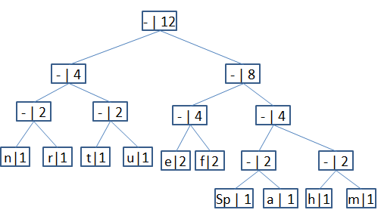

1110 011 101 101 1111 1101 000 1100 010 001 100 100

Huffman tree